**Detail Design**

**On**

***Library And Park Information***

**Course No: CSE 3204**

**Course Title: Software Engineering and Information System Project**

***Uttam paul***

***Student Id: 160236***

***&***

***Md. Lutful Hasan***

***Student Id: 160234***

**Project Manager:   
Dr. Kazi Masudul Alam   
Associate Professor,  
Computer Science & Engineering Discipline,  
Khulna University**

**ER Diagram:**

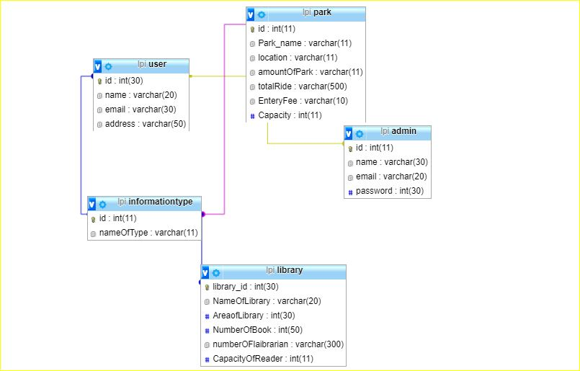

*Fig: ER Diagram*

**Class Diagram:**

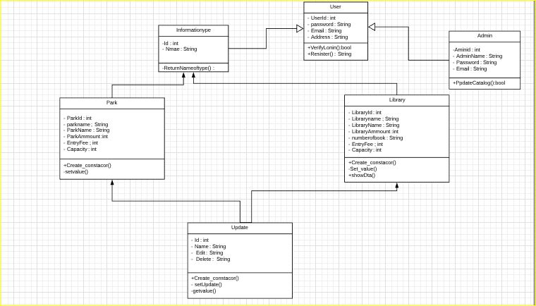

*Fig: Class Diagram*

**Details Class Digram:**

User:

Boolean String LogIn(String ID)

Boolean createVisitor (Visitor)

Visitot readVisitor(Visitor)

Admin:

Boolean String LogIn(String ID)

Boolean createVisitor (Visitor)

Library:

Boolean logIn(String ID)

Boolean creat Library (Library)

Park read Library (String Library _ID)

Boolean update Library (Admin)

Boolean delete Library (Admin)

Park search Library byID (string_ID)

List < Library > search Library byName(string Name)

List < Library > search Library byArea(string Location)

List <Books > search Library byName(string Book _name)

Library Review add Library Review(int user_ID)

Boolean Update Library Review(int user_ID)

Boolean delete Library Review(int user_ID)

Park:

Boolean logIn(String ID)

Boolean creatPark(Park)

Park readPark(String Park_ID)

Boolean updatePark(Admin)

Boolean deletePark(Admin)

Park searchParkbyID (string_ID)

List <Park> search ParkbyName(string Name)

List <Park> search ParkbyArea(string Location)

List <Games> search ParkbyName(string Game_name)

Park Review addParkReview(int user_ID)

Boolean UpdateParkReview(int user_ID)

Boolean deleteParkReview(int user_ID)

**User Interface:**

**LogIn page:**

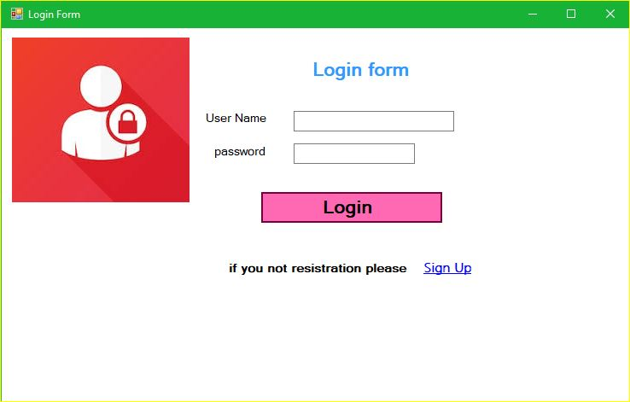

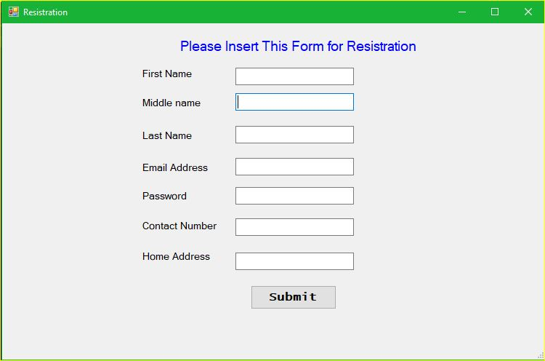**Resistration Form:**

***Park Section***

**Park information Home Page:**

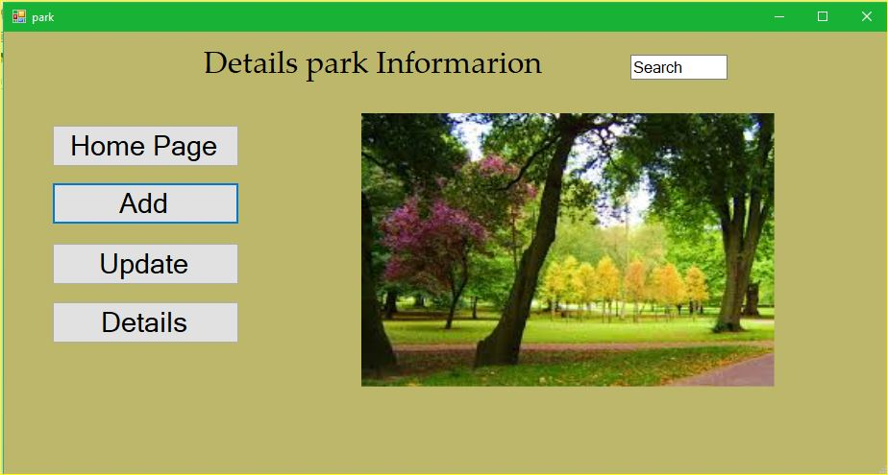

**Add Park Details:**

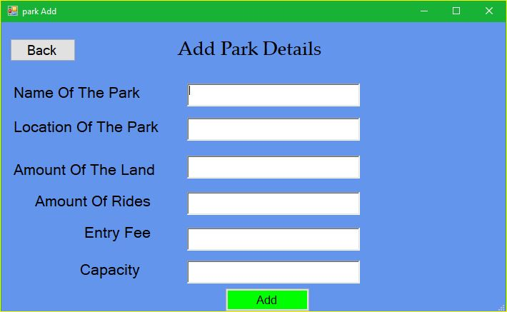

**Update Data park Information:**

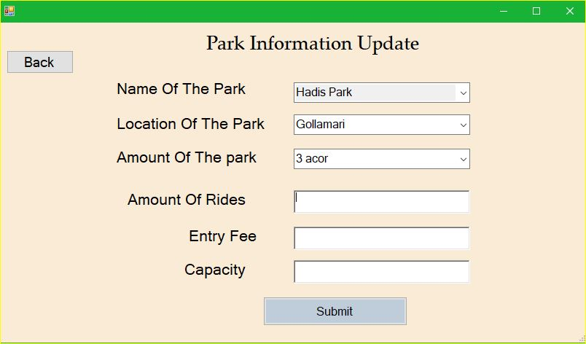

**Details Park information:**



**Edit Park Information:**

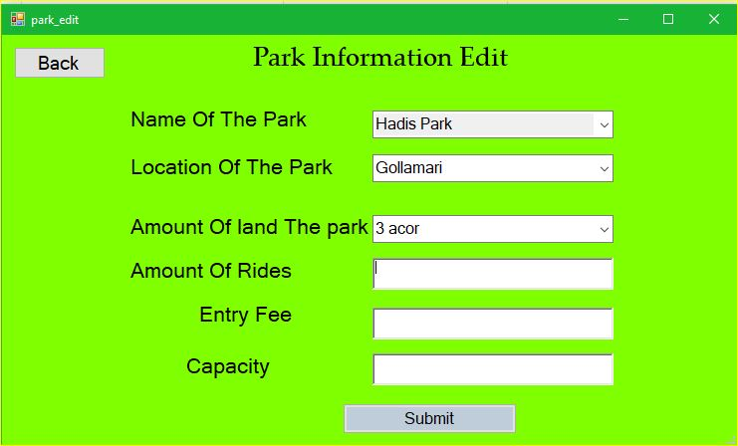

**Delete Park Information:**

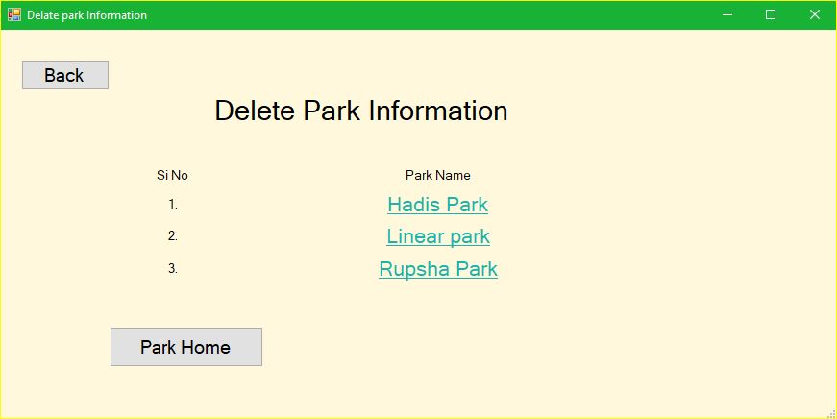

**Details Information:**

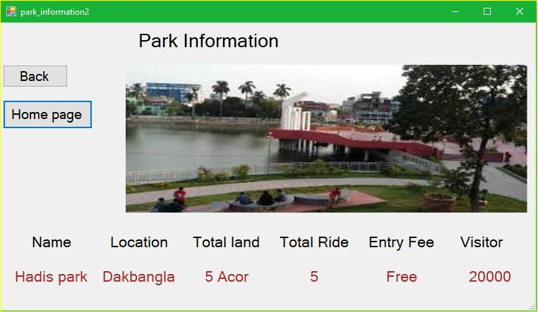

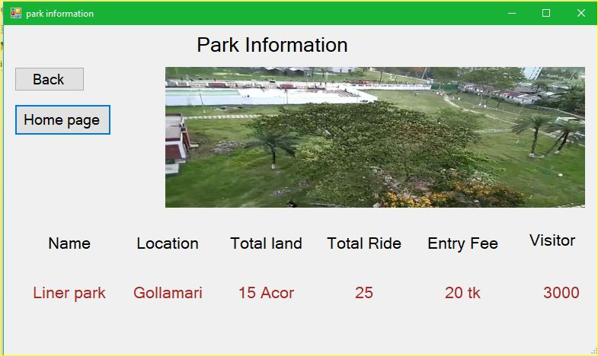

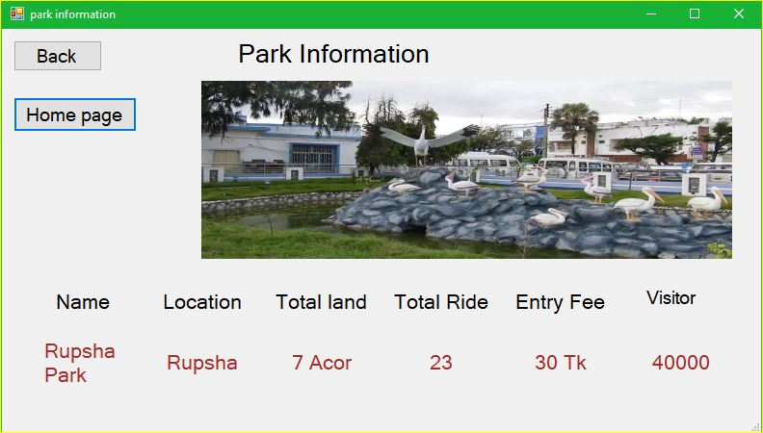

**Library Information**

**Library Information Homepage:**

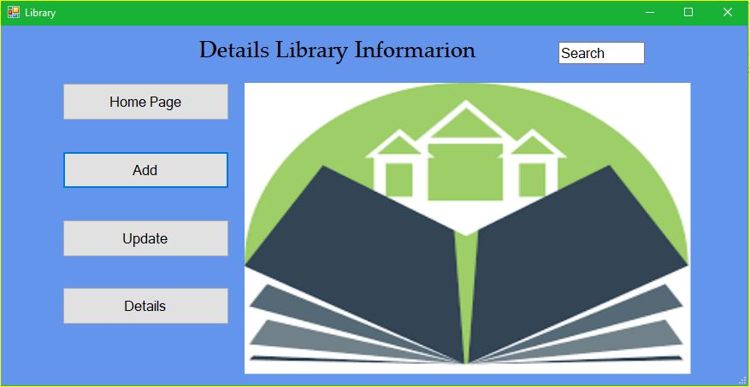

**Add:**

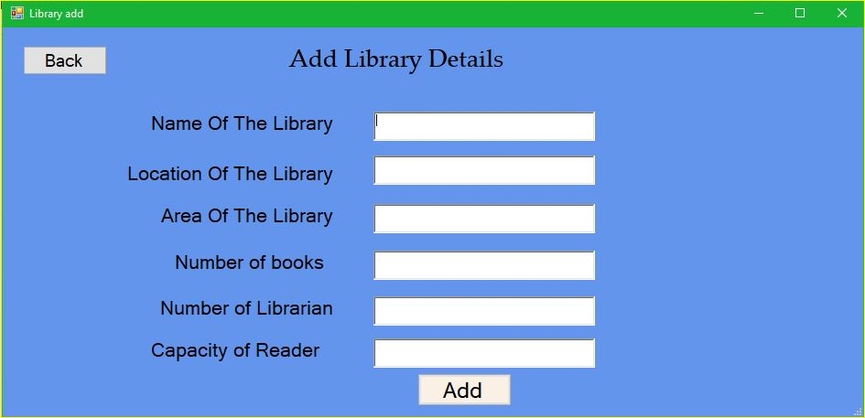

**Update:**

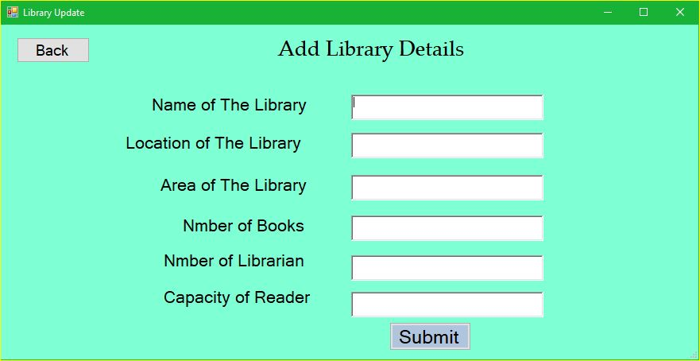

**Details:**

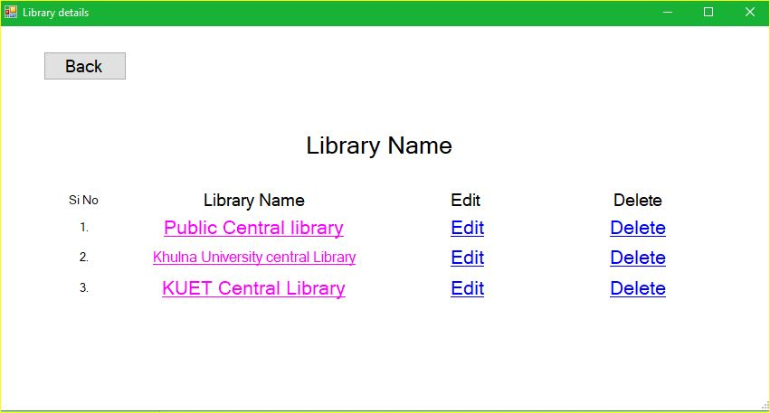

**Edit Information:**

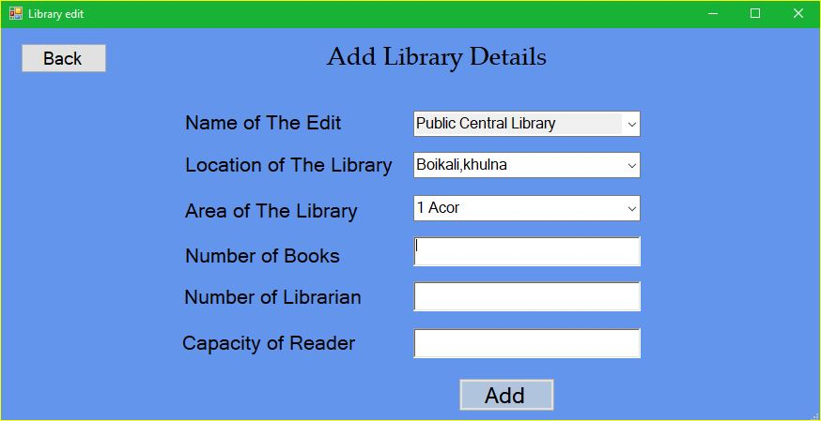

**Delate Information:**

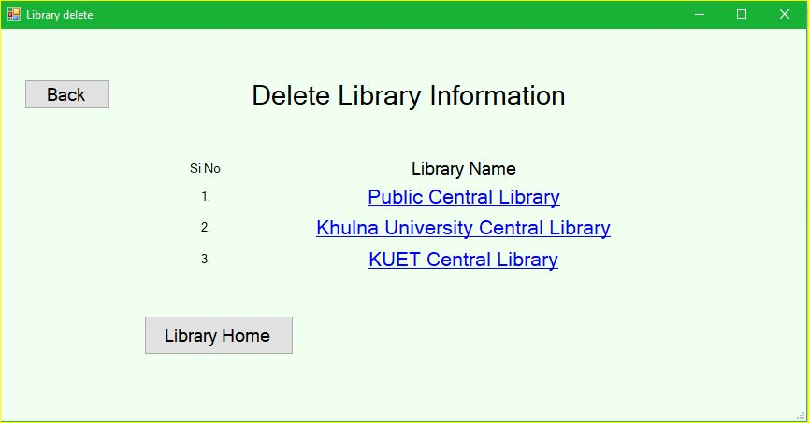

**Library Information:**

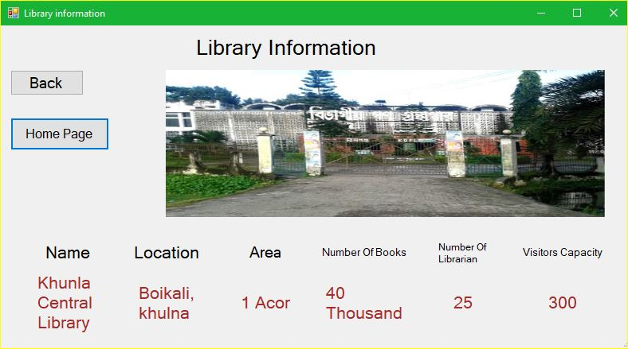

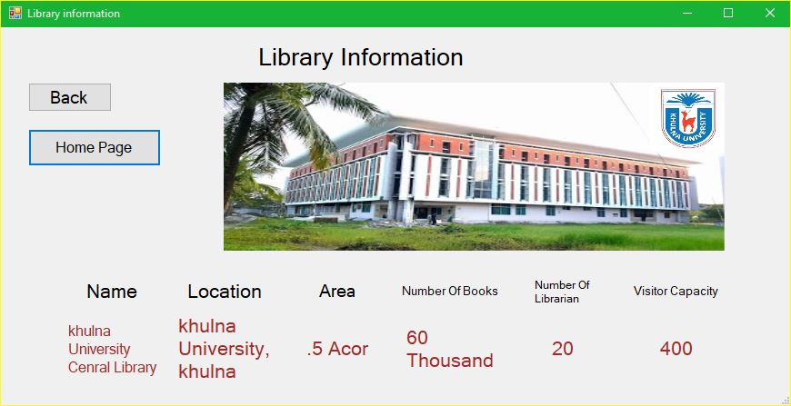

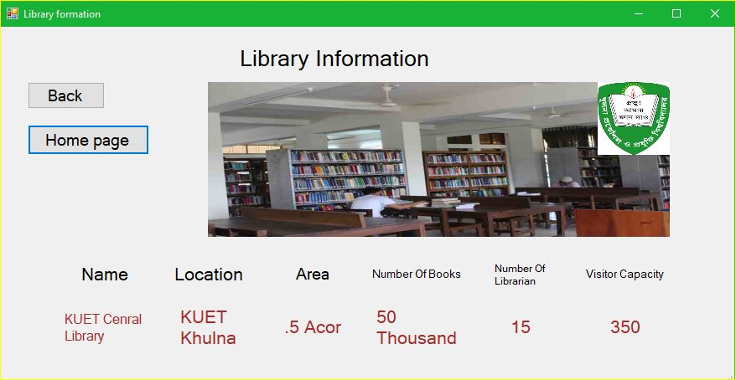

**Thank You**